**AutoFlow.ExcelToXmlTransformer** tool

**Description:**

This tool is used for transforming AP list excel to XML format, so ActivityCheckInstalledApp is able to use this XML file as Criteria source.

1. Command line only takes 1 parameter 🡺 file full path name (**Blank in full path is NOT allowed**).
2. Transform each sheets which it’s name contains with “AP List”: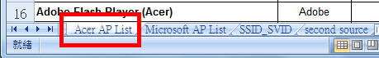
3. Column order **MUST BE** like below, or the value of XML could be wrong.
4. Device display name: is in 1st column (Title does not care. You could use other title.)
5. Vendor name: in 2nd column (Title does not care. You could use other title.)
6. Version: Must including “Win7 32bit” and “Win7 64bit” string in cell (2, 3) and (2, 5), do not care the order.
7. This tool gets the value from row 4, column 1.

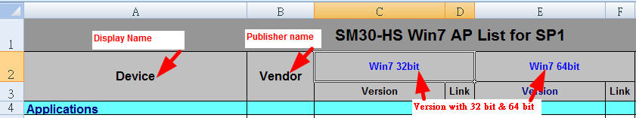

1. Output xml file name will be original file name + .xml and located in the same place.

For example:

Excel file path: C:\test\HummyBird.xls

🡺Output Xml path: C:\test\HummyBird.xls.xml

**How to use it?**

Type command line by following syntax:

Full path of ExcelToXmlTransformer.exe located (blank) AP list Excel file full path name.

**Example:**

If ExcelToXmlTransformer.exe and HummyBird.xls file are located in c:\Test folder:

1. C:\>**C:\Test\ExcelToXmlTransformer.exe C:\Test\HummyBird.xls**
2. C:\Test>**ExcelToXmlTransformer C:\Test\HummyBird.xls**

